TECHNICAL DATA SHEET

HALONIX TECHNOLOGIES PRIVATE LIMITED
Regd Office:-
B-31, Noida Phase – II, Dist.-Gautam Budh Nagar, U.P, Pin-201305

LED 20W Tube Light
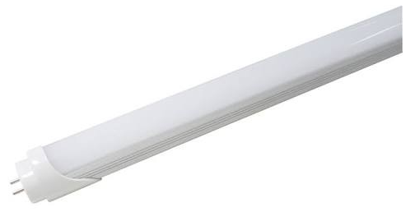
HLTLD-04-20-CW
As per IS 10322 & IEC 60598-1

Product Description: Energy efficient 20W LED Tube Light

Technical Specifications:
Main Housing: Aluminum extruded
Front Cover: PC
LED: LM80 certified LED
Lumen Maintenance: 50000 hours @ L70
Control Gear: Electronic, CC Driver
Internal Wiring: Insulated Cu wire
Hardwares: SS & MS Zinc plated and passivated
Ingress Protection: IP20
Operating Voltage Range: 140V~ 270V
Operating Temperature: -10ᵒC~ 50ᵒC

GA Drawing:

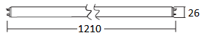

All dimensions in mm (Tolerance: ±5mm)

Electrical & Photometry Parameters:
Rated Voltage & Frequency | System Wattage | System Current | Power Factor | System Lumen Efficacy | CCT (As per ANSI) | CRI | THD | Driver Efficiency
240V, 50Hz | 20W±10% | <105mA | ≥0.95 | ≥100lm/W | 6500K | ≥80 | ≤15% | ≥85%

System Protections:
Open & Short circuit protection, reverse polarity protection, surge protection of 3KV internal.

Application:
Offices, hospitals, retail outlets, banks, etc.

Mounting:
Retrofit.

Note: Due to continuous efforts in developing products, improvement M/s Halonix Technologies Pvt Ltd reserves the right to make changes in the design and data and withdraw the luminaries without any prior notice. | Prepared by : | Sanjay Sharma | Industrial Luminaire :
 | Checked by : |  | Cat. Ref. :
 | Approved by : | Rajeev Chhabra | Document No :
As improvement in design & method of manufacturing is a continuous process, the product supplied may differ in details from above given data.

